**Exercise - Set up a Log Analytics workspace and Azure Monitor VM Insights**

First we need to create and configure a Log Analytics workspace

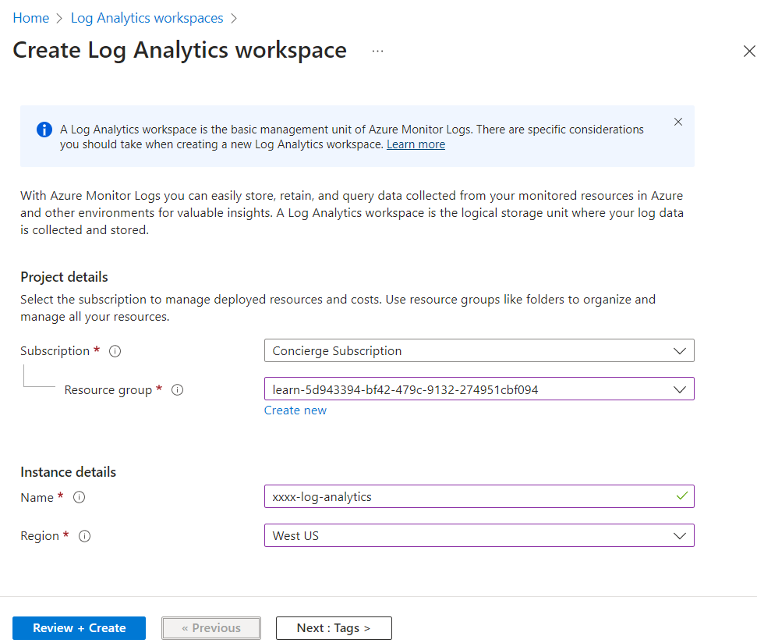

After we create the analytics workspace we need to make sure we access control mode, and select **Use resource or workspace permissions**. This setting changes the access mode to use the resource-context.

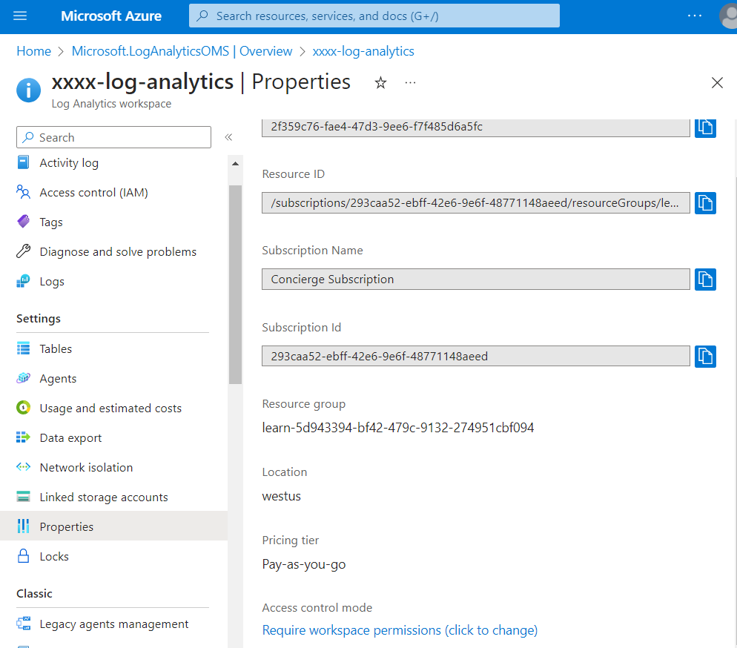

Next, we are creating two virtual machines

With the following command we are creating a sample virtual machine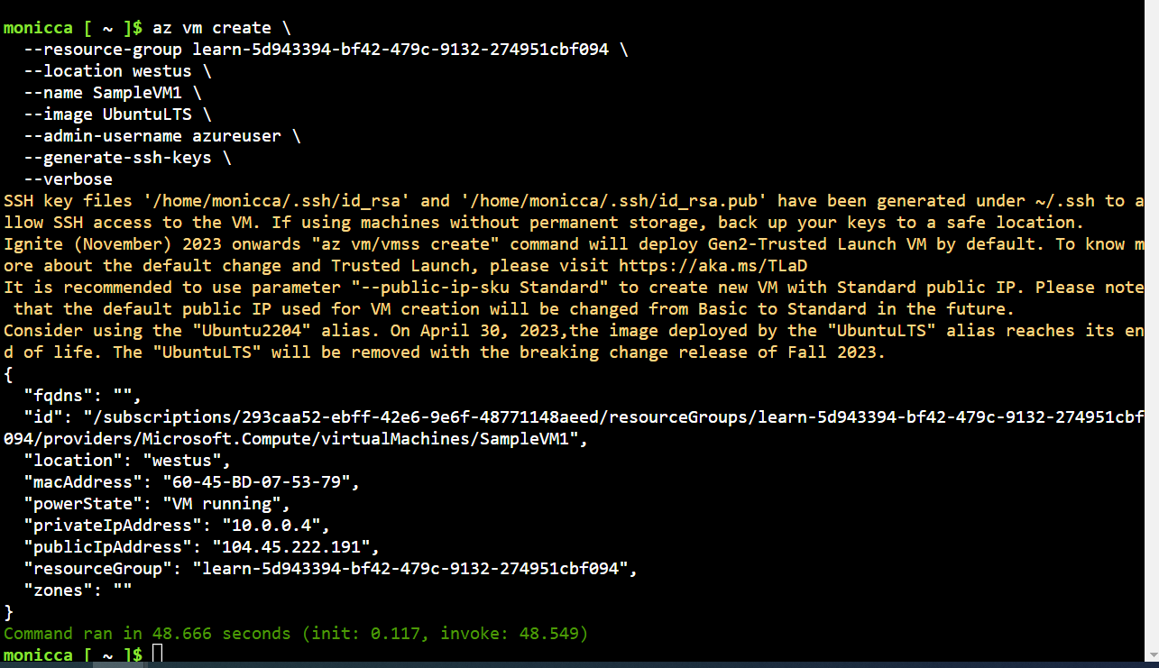

And creating the second virtual machine in bash

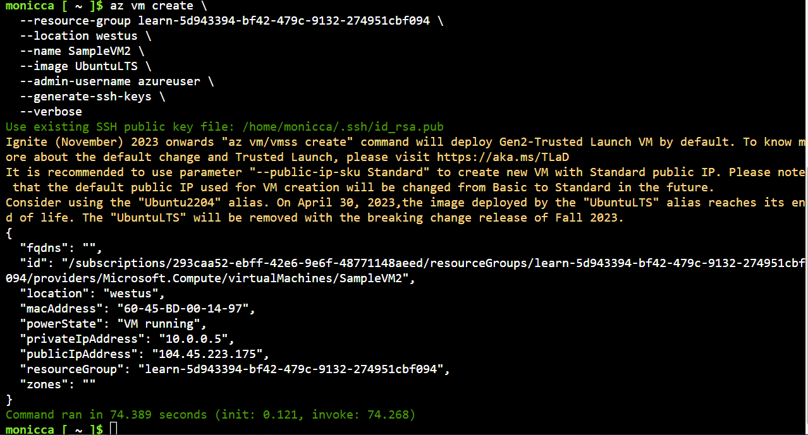

We can see the virtual machines that are created

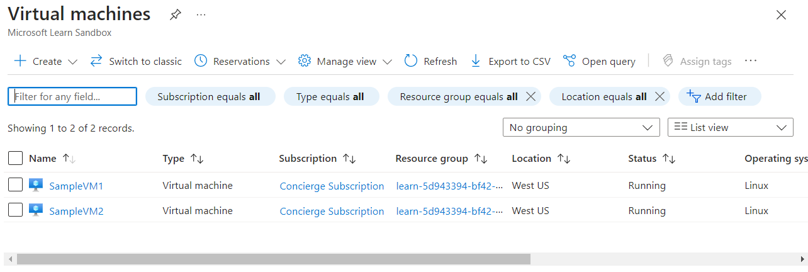

And configure the monitoring insights

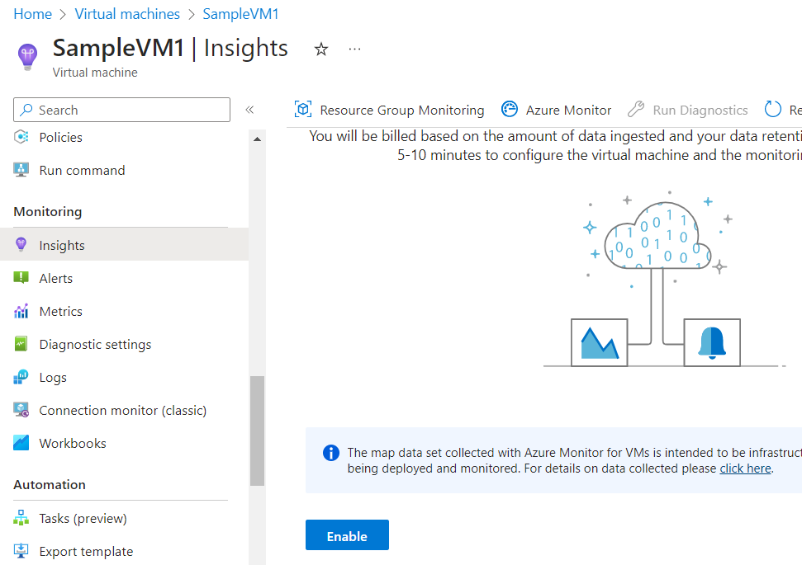

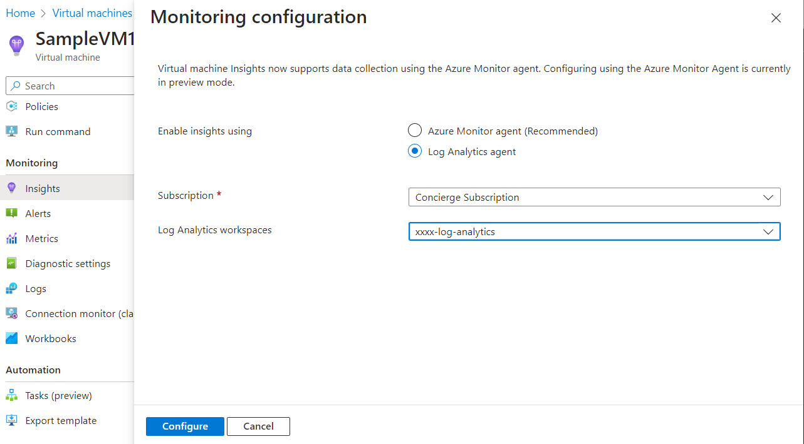

Configure monitoring for the second virtual machine as well

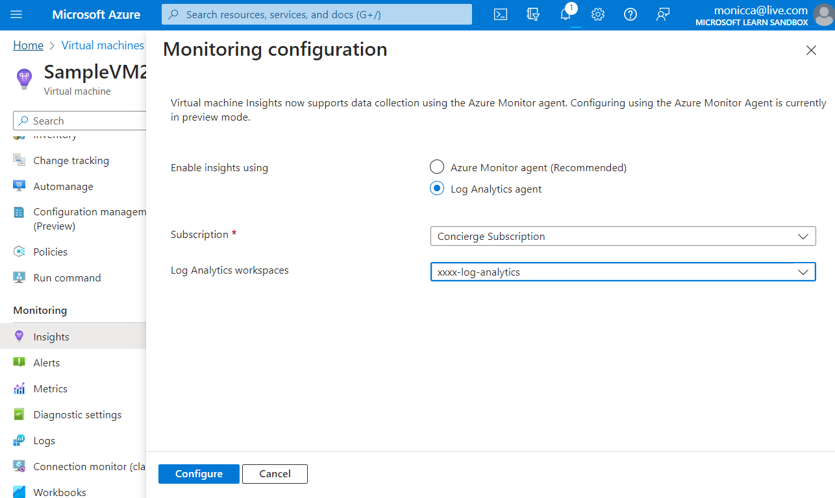

Reviewing the map with the dependencies like processes running, ports open, connection details, health of the virtual machine, machine properties, and Azure virtual machine properties.

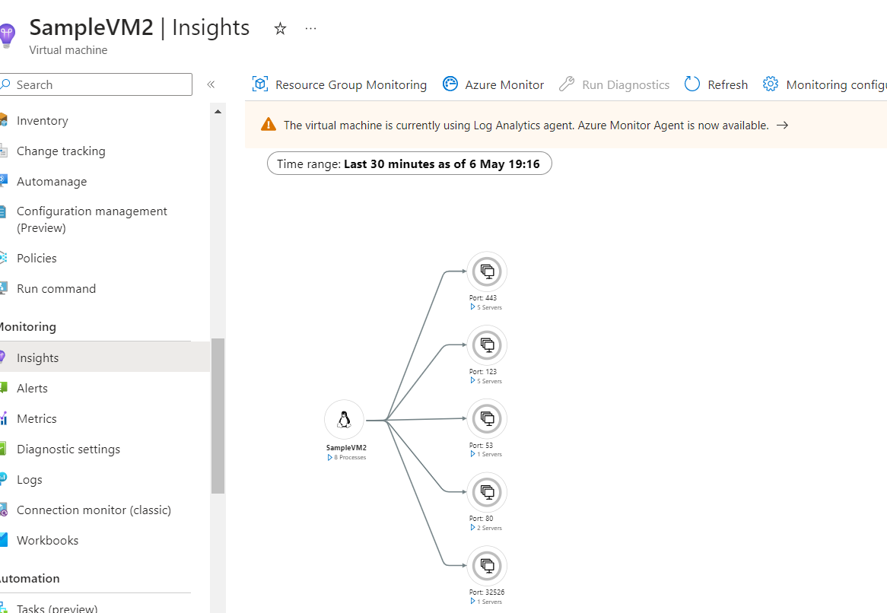

And in performance we can see different graphs

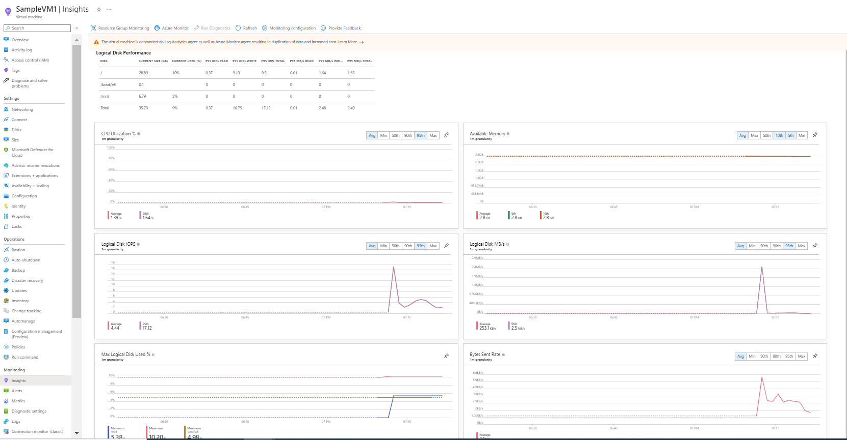

Selecting insight metrics

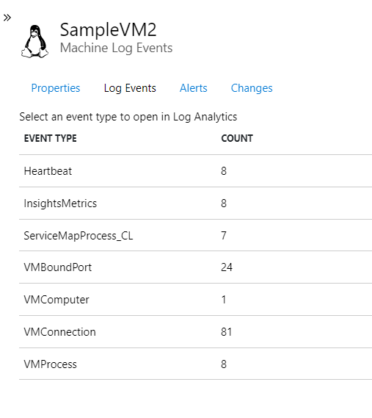

Log Analytics workspace opens with a prepopulated query showing the data being collected.

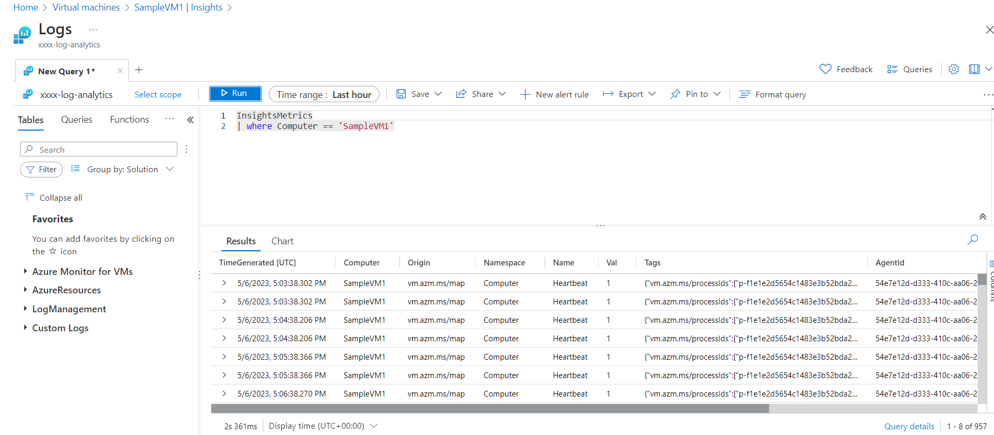

Next unit: Build log queries by using the Kusto Query Language

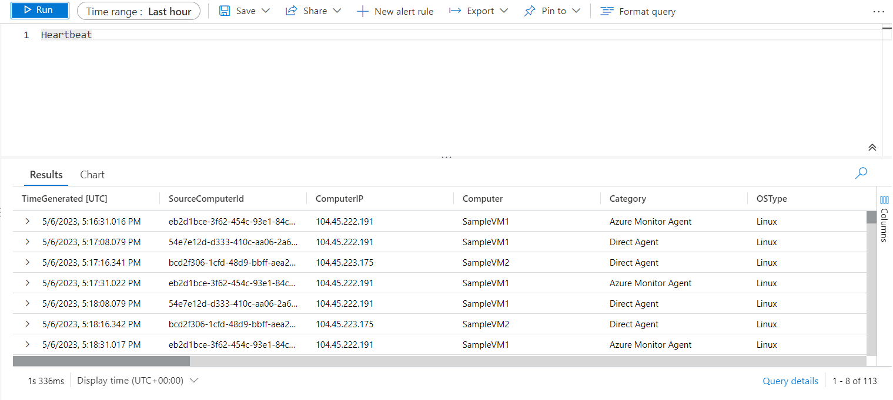

The Heartbeat table contains data on everything from OS type, OS major version, resource ID, and resource group.

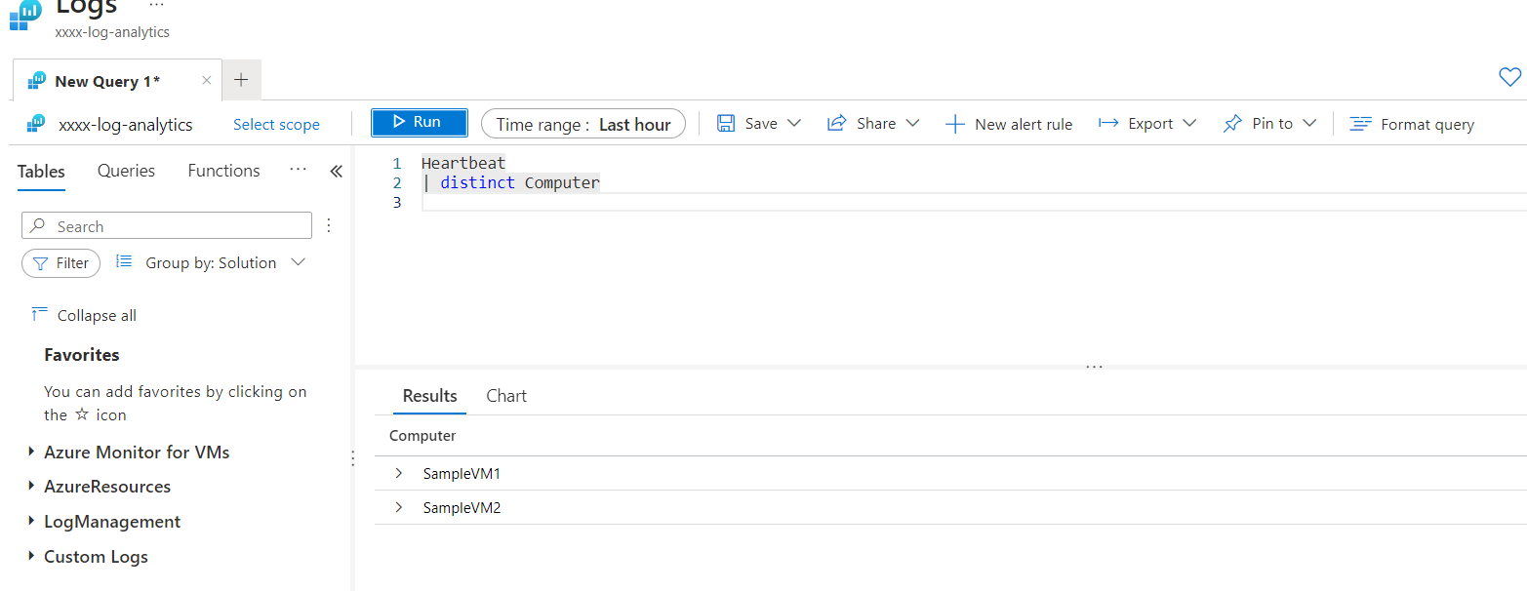

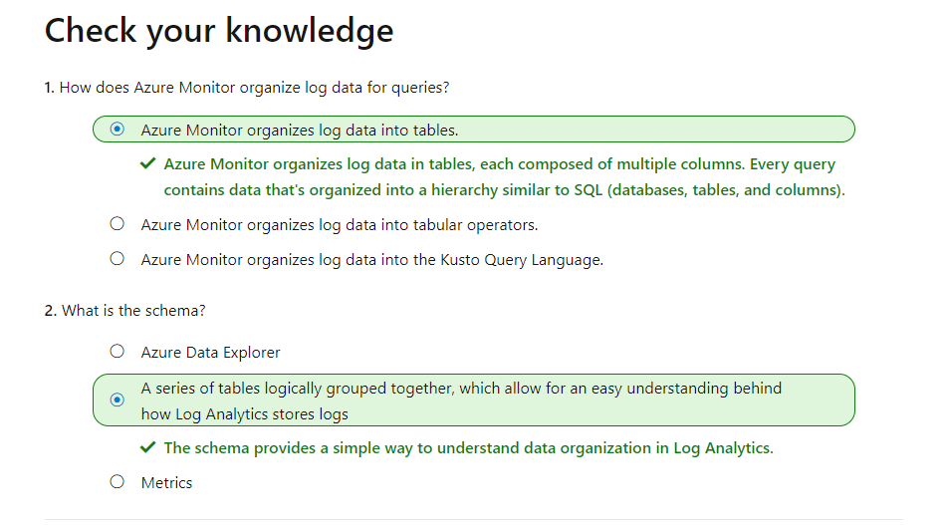

Exercise - Build log queries

Build a query by using the query pane

Filter the Resource Type and select Virtual Machine Scale Sets > CPU usage trends by computer

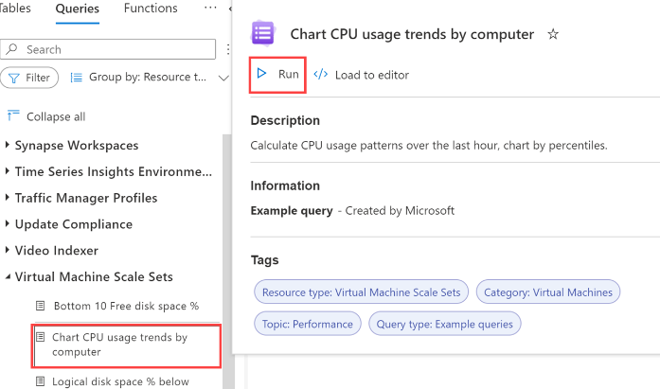

Experiment with a query in the query pane for average CPU usage

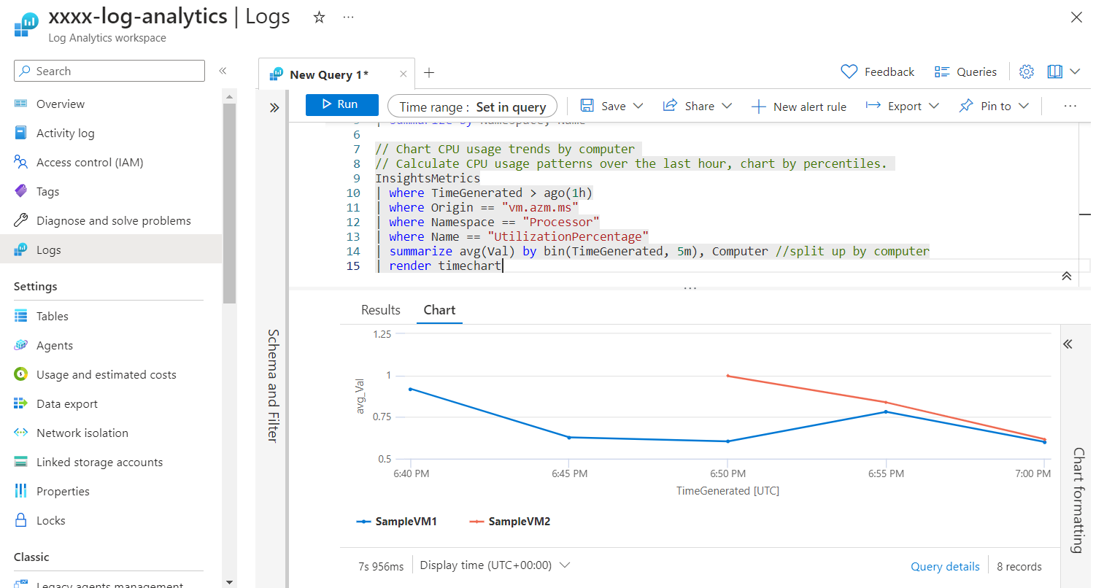

Edit the existing query to return the maximum CPU usage.

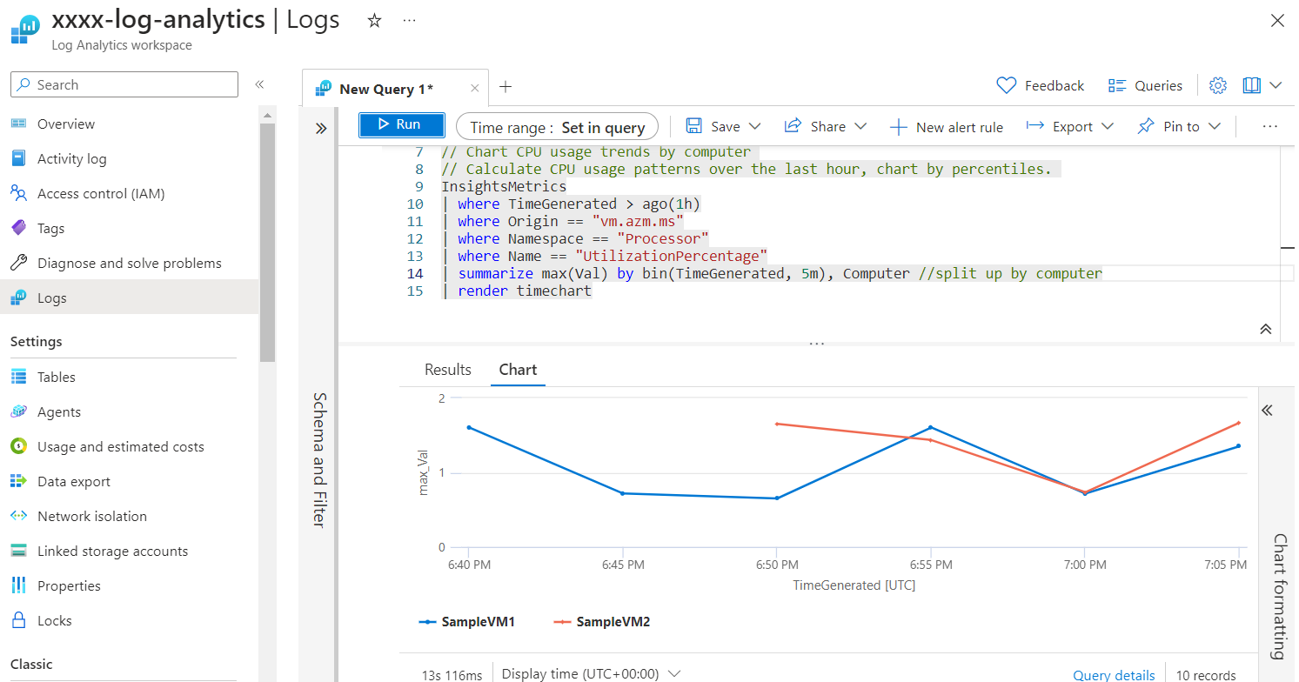

We can also pin each of these visualizations to a dashboard by selecting **Pin to dashboard** at the top.

